Pseudocode

String plaintext;

String encrypted text;

String decryptedText;

**public** **static** **boolean** stringInBound ( declare if the plaintext is in the range of ASCII code, else return true

**public** **static** String encryptCaesar(String plainText, **int** key)(return encryptedText)

**public** **static** String encryptBellaso(String plainText, String bellasoStr) (return ecryptedText with int key replaced by String bellaso.

**public** **static** String decryptCaesar(return decrypted code

screen shot of CryptoManagerTest

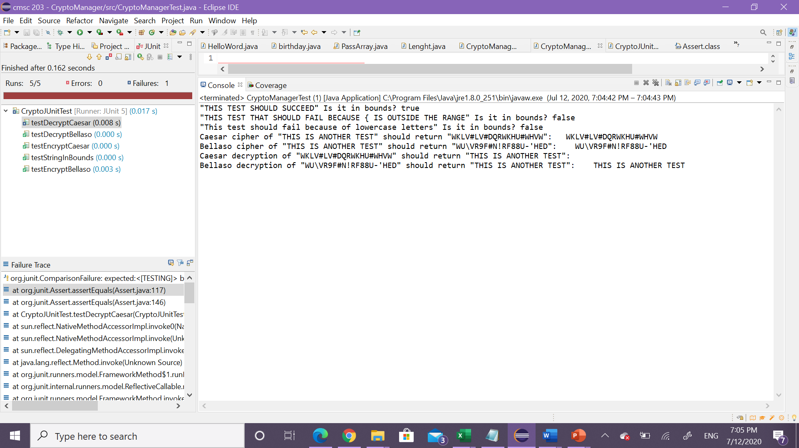

Test case junit

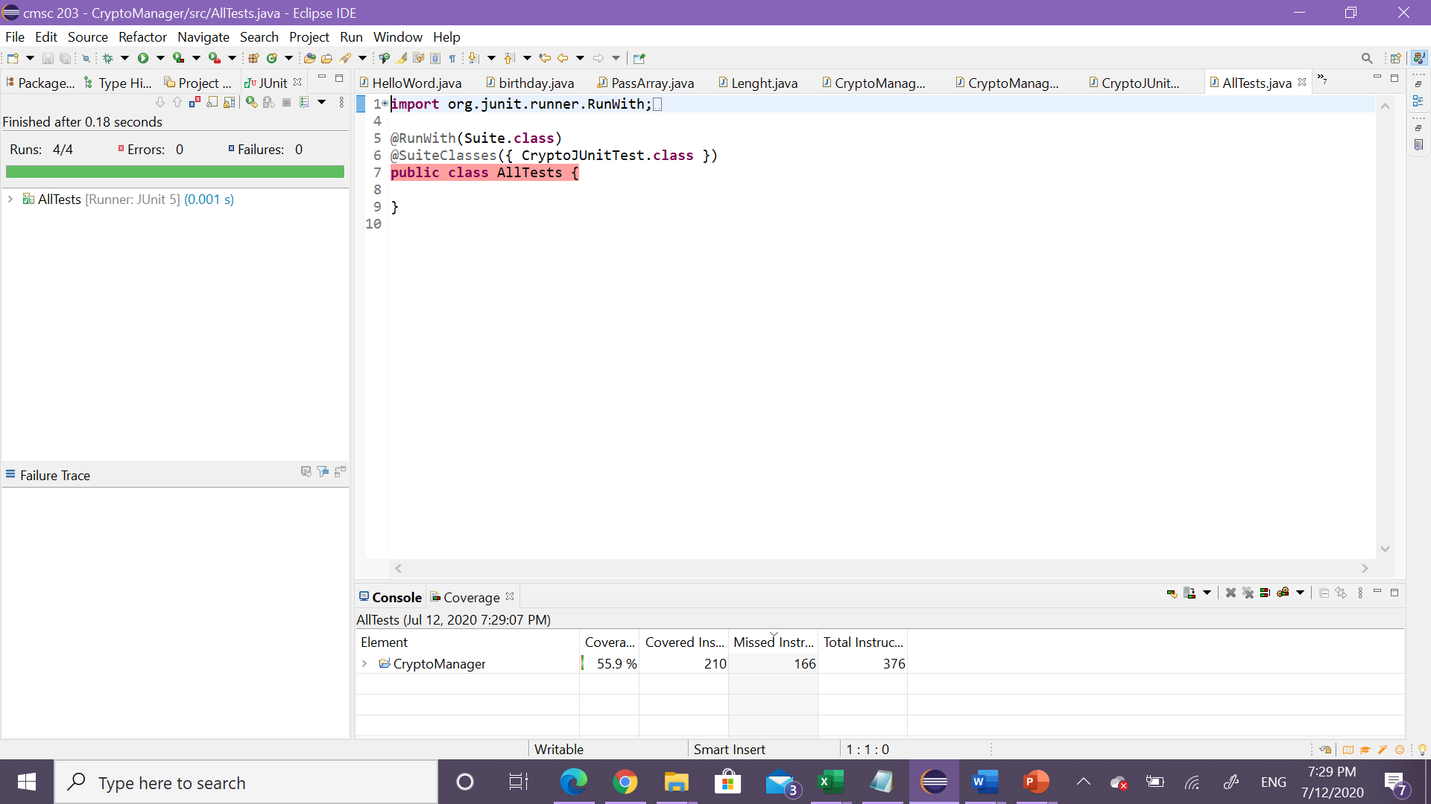

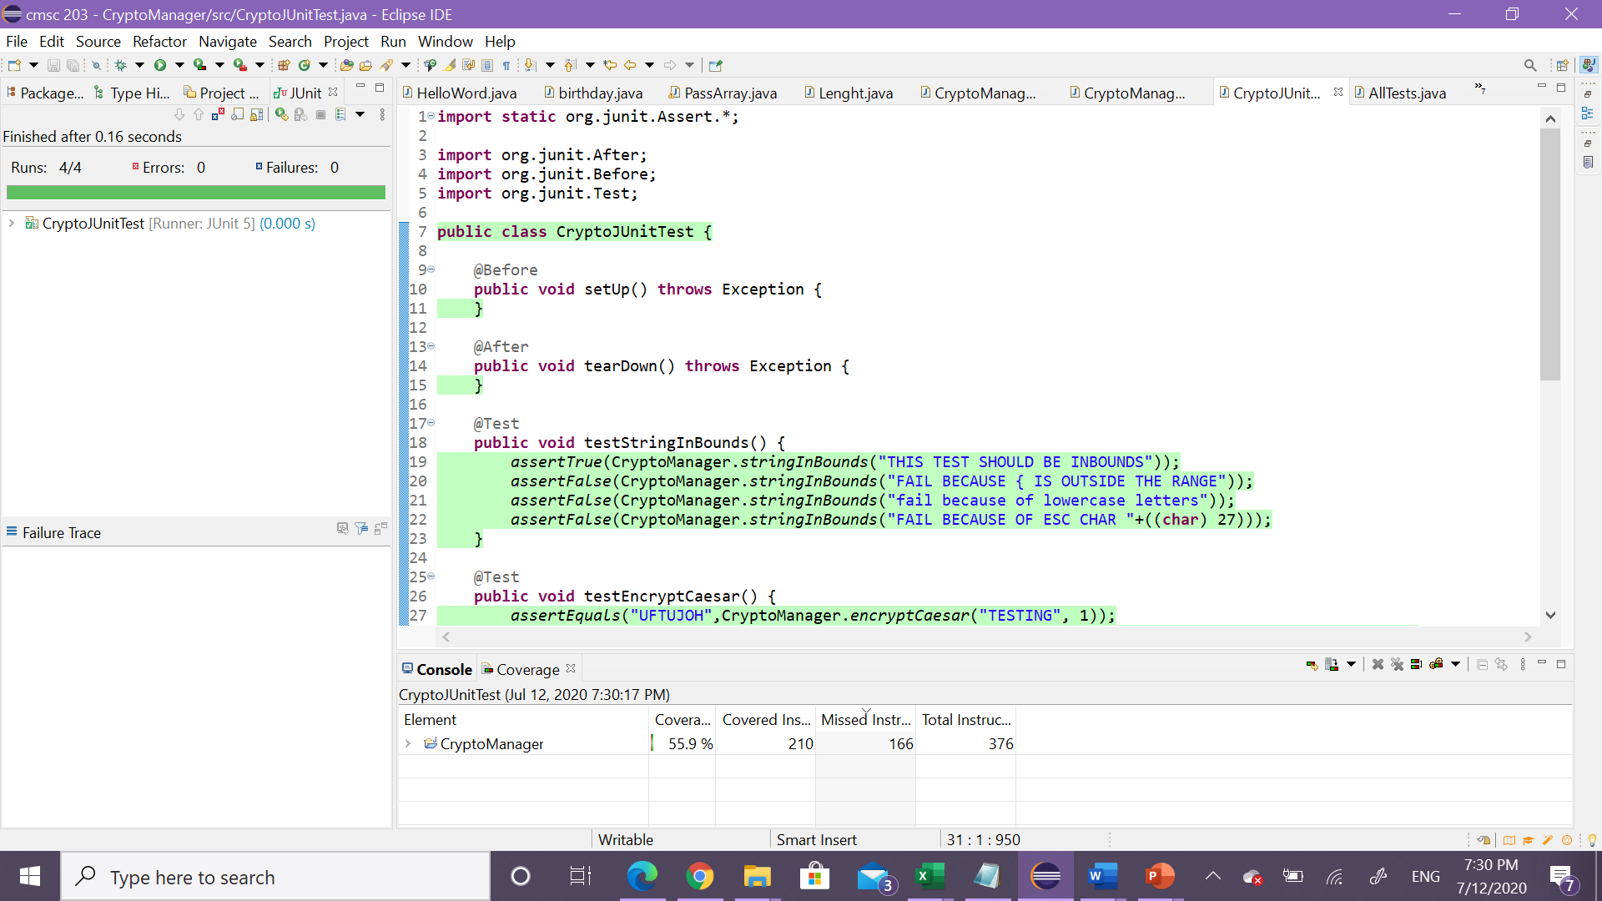

Learning lesson

Very difficult project, I learn how to used loop , to control a bound

How to used string and chart to process

How to use junit to test my different class in my code and how to use test class to test my input